**Objective**: Linearize and simulate an energy balance model with radiative and convective heat transfer.

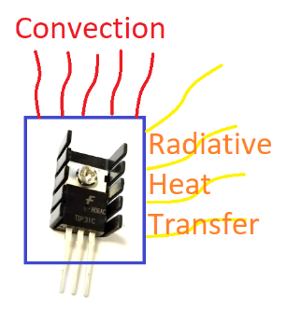

An energy balance equation includes convective and radiative heat transfer and is nonlinear because of the *T4* term.

Linearize the nonlinear differential equation by computing the partial derivatives γ and β with respect to the heater value (*Q*) and temperature (*T*). The γ and β are constants when evaluated at steady state conditions. The right hand side of the differential equation is a function *f(T,Q)* of only *Q* and *T* while the other values are constants.

$$\frac{dT}{dt}=f\left(T, Q\right)≈{\left.\frac{∂f}{∂T}\right|}_{x_{0}}∙\left(T-T_{0}\right)+{\left.\frac{∂f}{∂Q}\right|}_{x_{0}}∙\left(Q-Q_{0}\right)$$

**Condensed Linear Form**

$$\frac{dT}{dt}≈γ\left(T-T_{0}\right)+β\left(Q-Q_{0}\right)$$

with partial derivatives evaluated at steady state conditions ($Q_{0}=0, T_{0}=23℃$):

$$γ={\left.\frac{∂f}{∂T}\right|}_{x_{0}}$$

$$β={\left.\frac{∂f}{∂Q}\right|}_{x_{0}}$$

Use values:

* α=0.01
* Ta=23oC
* *m*=0.004 kg
* ε=0.9
* *A*=0.0012 m2
* cp=500 J/kg-K
* *U*=5 W/m2-K
* σ=5.67x10-8 W/m2-K4
* T∞=23 oC

to simulate the change in temperature over the 5 minutes when heater *Q* is adjusted to **75%**. Compare the simulated temperature response to data from the TCLab as well as the nonlinear model. Add the linear simulation prediction to the [solution from the prior TCLab exercise](http://apmonitor.com/pdc/index.php/Main/TCLabRadiative).

**Solution**

$$\frac{dT}{dt}≈γ\left(T-T_{0}\right)+β\left(Q-Q_{0}\right)$$

$$γ={\left.\frac{∂f}{∂T}\right|}_{x_{0}}=-\frac{UA}{mc_{p}}-\frac{4εσA}{mc_{p}}{T_{0}}^{3} \\ β={\left.\frac{∂f}{∂Q}\right|}_{x_{0}}=\frac{α}{mc_{p}}$$